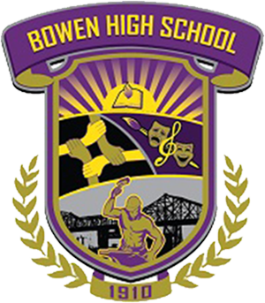

BOWEN HIGH SCHOOL INFORMATION NIGHTS FOR PARENTS – CLASS OF 2018
(PARENTS SHOULD PLAN TO ATTEND ONE SESSION)

THURSDAY, NOVEMBER 9, 2017@7PM
THURSDAY, JANUARY 11, 2018 @11AM
SATURDAY, MARCH 10, 2018 @10AM
THURSDAY, APRIL 12, 2018 @7PM

LEARN ABOUT THE FOLLOWING:
- GRADUATION REQUIREMENTS
- COLLEGE APPLICATIONS AND ADMISSIONS
- SAT INFORMATION
- FINANACIAL AID (FAFSA) AND SCHOLARSHIP IMPORTANT DATES
- SENIOR DEADLINES AND UPDATES

